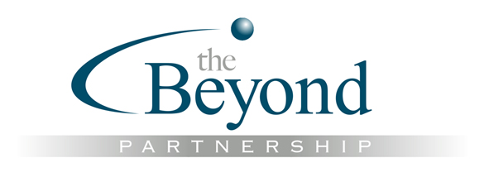
Masterclass in Spiral Dynamics®

Chris Cowan and Natasha Todorovic

5 & 6 November 2009

“We are excited by this Masterclass. This is a unique event, open only to people who have completed SD2 with Chris and Natasha. It is your opportunity to shift your Spiral Dynamics practice to the next level. It has been designed to support you. Bring your questions and Chris and Natasha will bring their answers and share their latest thinking, applications and experiences.”
Paul King & Marie Faire

Turning Spiral Dynamics theory into practice can raise many questions. We can also sometimes fall into poor habits and generalisations in our understanding and interpretation. As Chris and Natasha frequently emphasise accurate diagnosis is the key to effective intervention.

The Masterclass will include:

- A hands-on profiling tools review, highlighting the common and frequent mistakes even qualified people are making. Chris and Natasha will share tips and techniques for more effective tool use in various contexts. You will be welcome to bring your case studies for feedback and discussion.

- An open-forum where you decide the content.
You will be invited to forward your requests and questions for the forum a couple of weeks in advance.

- Chris and Natasha sharing stories of their latest examples of application and news of latest developments in their thinking.

If you are bringing content for discussion we ask that it is "real", i.e. you have applied one or more of the Spiral Dynamics tools. (The tools offer a consistent measurement approach and reference).

Course Qualification
This Masterclass is open only to those who have completed SD2 training with Chris and Natasha.

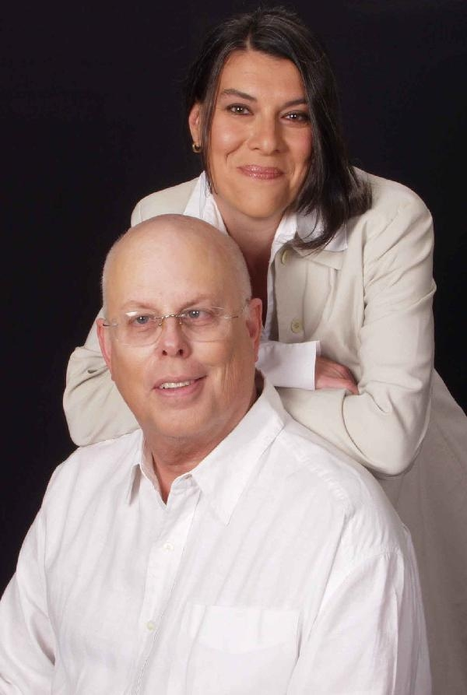
“Ready for another step? We're conducting this special two-day seminar for experienced people who are anxious to expand their knowledge. Join us in this opportunity to work together to refine practice, application, and to sharpen the leading edge of our field.”
Chris Cowan & Natasha Todorovic

Venue
tba

Early Bird Price (Paid by 14 September)
- Self sponsored individuals and not for profit organisations - £500 (+VAT)
- Corporate Sponsored - £600 (+VAT)

Standard Price (Paid after 14 September)
- Self sponsored individuals and not for profit organisations - £650 (+VAT)
- Corporate Sponsored - £750 (+VAT)

Booking
To book or to discuss this training please contact The Beyond Partnership Ltd, 2 Holbrook, Bromham, Wilts, SN15 2DH.
Tel: 01380 859106
Email: info@thebeyondpartnership.co.uk

(Spiral Dynamics is a registered trademark of the National Values Center, Inc. and is used here with permission)

